THE JUBILEE SYSTEM OF VOLUME II OF STUDIES IN THE SCRIPTURES

Rodney Hugelman

Man seldom appreciates what he has until it has slipped from his grasp. He is continually reaching for something else and he must put aside the one to pick up another. Man has now left this earth behind and put forth his hand toward the gleaming alabaster moon only to find a cold and sterile orb—without life. When they looked back they saw a blue and white jewel set against the black velvet of space. Earth, with its clouds of pure water—planet alive and filled with life. They have come to appreciate what God had provided for them as few men before them—as men who had left it behind and with the prospect of perhaps never seeing it again. And what of their return? If their attitude is precise they live. If not, they are destroyed as they re-enter earth’s atmospheres.

Our course is much the same. If our attitude is not precise we shall be destroyed for we reach for a higher star and we cannot turn back. Let us therefore consider a feature of the harvest Message which is more precise than any Lunar trajectory and far more important as we shall see.

Read carefully Lev. 25:8 to 13. This feature of the Law is clear—in the 50th year a restoration work was performed. Next carefully read paragraphs one and two of page 173 of Volume II—the first paragraph quotes Matt. 5:18. A very important point is that “the Law foreshadowed ‘GOOD THINGS to come.’” Now turn to page 178 and 179 and read the bottom paragraph on page 178 and the first paragraph on page 179. Note particularly the thought that the Jubilee type points “unmistakably to ‘the Times of Restitution,’” and that “the work of completely restoring (to the obedient) all that was originally lost will require all of that age of restitution.”

In the following pages we shall discuss the concept of the Jewish Jubilee and in particular its antitype. The Jubilee cycle method of indicating the antitype will be examined, as presented by Bro. Russell in Vol. II of S. S, which the reader is urged to study carefully along with Vol. VI, pages 50 and 51. This will be scrutinized to the best of our ability in light of Christian reasoning, Scriptural support and mathematical accuracy and significance.

Brother Russell has presented to us a rather remarkable picture of the antitypical significance of the Jewish Jubilee. This he views from three entirely separate standpoints: i.e., as a prophecy fulfilled, as one of the Shadows of the Law, and finally as a picture applicable to the close of the Millennium. The first two applications are found in Chapter VI of Vol. II of S. S. while the last application is found in Vol. VI, pages 50 and 51. These each will be considered in order.

The Jubilee as Prophecy Fulfilled

Carefully read Jer. 25:11; 29:10 and 2 Chron. 36:20, 21.

At this point it should be noted that the 70 years must refer to the Sabbath or rest of the land under the Jubilee year and not the 7th Sabbath year arrangement. The proof is that the Jubilee rest years will be shown to be in full harmony with other Scriptures and sanctified reason and at the same time to correspond exactly to the 70 years allotted by the LORD, no more, no less. On the other hand, if we assign this prophecy to the 7th year rest years, then the prophecy becomes meaningless, for Israel had certainly not satisfactorily kept these sabbaths either. Since at the time of the pronouncement by the Lord they should have kept 138 such sabbaths, this would assume that they had in fact kept 68 of them perfectly. (Entry into Canaan until the 70 years desolation is 969 years. 969 plus 7 equals 138 sabbath years plus 3 years). Nor is it reasonable to seem that the 70 years could be a token punishment for their failure. The justice of the Law arrangement was absolute, an eye for an eye and a life for a life. Indeed, upon this divine principle hangs the philosophy of the ransom itself.

If however, we take this as a reference to the Jubilee years only, then no such difficulty exists for now the 969 years to the announcement of the 70 years desolation by the LORD includes but 19 such rest years. Further, the LORD now required that the land enjoy her full rest of 70 years which He had intended from the beginning and which requirement He now enforced in full at that time.

Israel’s failure to keep the Jubilees was of course no surprise to the LORD. Perfect wisdom had been employed once again that Israel might be used to mark the stream of time in GOD’S chronology to those who should be found watching at the due time. Thus its secret remained hidden for more than 20 centuries.

From this observation one can see that the LORD intended 70 Jubilees which the Israelites covenanted to keep. They had already attempted 19 but failed in this attempt. Thus it was that the LORD required the full 70 years of rest for the land. From Canaan to the desolation was a period encompassing 19 x 50 equals 950 years. The 51 remaining periods are not 50 years in length, however, but 49 years each since the 50th years, or Jubilee rest years for the land have already been accounted for in the full 70 years desolation once for all and must not be counted twice. These 51 periods of 49 years yield 51 times 49 equals 2499 years. Thus the 70 prophetic Jubilees provide us with 950 plus 2499 equals 3449 years in all. From the entry into Canaan to Oct. 1874 is exactly 3449 years! True to God’s word, Oct. 1874 marked the return of our Lord and the setting up of the kingdom long sought for—the Jubilee within which all mankind would return unto their original inheritance.

It is also interesting to note that while 2 Chron, 36:20, 21 refers to the 70 years desolation as “sabbath” of years, this does not conflict with our understanding for not every sabbath is a 7th year sabbath as we shall now see. “Sabbath” is not a title reserved exclusively for the 7th year sabbath but simply a word meaning rest or intermission. Jubilee year was a “rest” year or “sabbath” of rest for the land.

“Sabbath” is translated from 3 Hebrew words in Strong's concordance: #7673, 7676 and 7677. Only 7677 has the implication of a special holiday and even then it refers sometimes to the 7th year sabbath sometimes to a 7th day sabbath, or in connection with certain feasts, even to an 8th day sabbath of rest. See Lev. 23:39.

In the case of 2 Chron. 36:20, 21 the word “sabbath” is 7673 which is not translated “Sabbath” anywhere else in the Scriptures. It is, however, translated “rest” in many places and often has no connection with either the Jubilees, 7th year, or 7th day sabbaths. See for example Exodus 5:5.

Thus we see that when the Scriptures refer to a “sabbath” we know it indicates a rest of some kind, but we must let the context of the Scriptures themselves tell us what kind of a sabbath is referred to; i.e., Jubilees, 7th year, 7th day, 8th day, pentecost, etc.

The Jubilee as a Shadow of the Law

Matt. 5:18, “For verily I say unto you, Till heaven and earth pass, one jot or tittle shall in no wise pass from the law, till all be fulfilled.”

We begin by noting that the above Scripture does not say that the Law would remain only until broken. If this were true then the Law never existed for none could or did keep it for centuries until the man Christ Jesus. It was God’s Law. He gave it and He would decide when, where and how it would be fulfilled and not those who bound themselves under it. So it was with the Jubilee. Since the entry into Canaan, Israel had attempted 19 Jubilees up to the time of the pronouncement of the desolation of the land. They had not kept these Jubilees but were nevertheless bound to them under the Law. It was the LORD, not Israel, who declared an end to this feature of the Law and He and He alone had the authority to do so.

It might be asked, why did the Lord wait? Of course since Israel did not faithfully observe even the first Jubilee there is simply no answer—unless we can by faith perceive that it was for a very definite purpose at a very definite time and above all for us unto whom the ends of the ages have come. Even the delay of the captivity 19 years (from 625 B.C. the date of the last Jubilee) to 606 B.C. was necessary to work out the 2520 years of Gentile Times satisfactorily. Yet remarkably, (Appendix D) though this execution was delayed 19 years, its judgment was pronounced precisely on time in 625 B.C. by Jeremiah 24:1, “The word that came to Jeremiah concerning all the people of Judah in the fourth year of Jehoiakim the son of Josiah king of Judah, that was the first year of Nebuchadnezzar, king of Babylon.” And Jer. 25:11, “And this whole land shall be a desolation, and an astonishment; and these nations shall serve the king of Babylon 70 years.”

With the Scripture, Matt. 5:18, and the close of Jubilee feature of the Law following the 19th Jubilee attempted by Israel in 625 B.C, we look for the fulfillment of this law feature beginning at that very point of time. Note that the antitype begins here in this view of the type whereas in the preceding view, the antitype began in Oct., 1874. Thus we should expect some differences in the two methods of reckoning, although both should indicate in their respective way, Oct., 1874 as the beginning of the Jubilee of restitution.

One very important difference is the fact that in this instance the antitype will be shown to include the Jubilee years of each cycle. Therefore, the close of the 49th year of the last cycle must fall an Oct., 1874, just as in the previous case and the last 50th, or Jubilee should begin at that same time—the Jubilee year now being 1,000 years rather than one year. Including the 50th Jubilee year of this last cycle requires one more year or 3450 years in all if this method is to agree with the foregoing one in predicting Oct., 1874 as the beginning of this Jubilee of restitution.

Remembering the Jubilee arrangements in the type as 7 x 7 equals 49, which introduced the 50th Jubilee year we now apply this principle on the larger scale of the now fulfilled reality; i.e. 50 x 50 equals 2,500. Just as seven sevens lead to the Jubilee of the type, now fifty fifties in the antitype should proclaim and introduce the great Jubilee of restitution, and 950 plus 2500 equals 3450 years with the necessary additional year with respect to the previously shown analysis of the Jubilee in prophecy—just as was required.

In the first study, Oct., 1874 marked the beginning of the Jubilee of restitution and was the end of the 49th year of the last, 51st. cycle of 49 years. No Jubilee (50) year was shown in this method since they all were accounted for at the same time in the 70 years desolation. In the present analysis, however, the Jubilee years are included in each cycle. Nevertheless, precisely as expected the end of the 49th year of the last cycle falls on Oct., 1874—exactly in full agreement with the first study. The 50th year is of course the Jubilee year itself and begins on Oct., 1874 precisely on schedule. Now, however, this last Jubilee is not one year but a full 1,000 years in length!

Thus we see that both methods are in full agreement to the very day. What might have seemed like a discrepancy of one year turned out to be a definite requirement in order that these two different methods indicate Oct., 1874 as the beginning of the Jubilee of restitution.

Now please turn to Vol. II, page 187, par. 2 and read through page 188, par. 1. Note the important point that “On the strength of this inspired statement alone, we have clear evidence of the fact that our Lord’s second advent was due when the Time of Restitution were due to begin, viz., in Oct., 1874, as marked by the Jubilee arrangement.”

Next read carefully Vol. II page l87, paragraph 1.

The Jubilee as a Picture

Turn to Psa. 23:1-6, Numbers 21:8 and Heb. 10:1. At this point it is well to point up the difference between a type or shadow and a picture. A “shadow” is as its name implies, not the reality but its shadow and like any shadow, if followed to its end one finds the reality. Where the shadow stops the reality must begin. A “picture” on the other hand is a symbolic representation of a reality and is not linked inseparably time-wise to the reality. Thus, a shadow may be a picture as well, but a picture may not be a shadow.

The Apostle Paul declares that the Law was such a shadow. Heb. 12:1, “For the law having a shadow of good things to come, and not the very image of the things…” It is for this reason Bro. Russell insisted that the Jubilee, a feature of that Law, commence its antitype at the close of the type. When the shadow of the Jubilee ceased, the reality began. On the other hand “pictures” such as the serpent in the wilderness (Num. 21:8), picturing the beating power of the returned Lord in the Millennium remain only pictures and when the serpent itself was no longer held up before the people, this did not require that the Lord set up his kingdom there on the spot at that very moment.

So, we should expect that the shadow of the Jubilee might also be used in a secondary sense as a picture; that is, whenever a 49 appears followed by a 50th we should look to see if the LORD has provided some significant lesson for us pertaining to a restoration of some kind. This is in fact the case since the close of the millennium in A.D. 2874 marks, we believe, the end of the 49,000th year from creation and hence the beginning of the 50,000 year when all is restored to the Father that He may be once again all in all and in personal relationship with His creation. (See Vol. VI.. pages 50 and 51 of Studies in the Scriptures.)

Notice that it is not necessary to say “which of these Jubilee presentations shall we accept” since each has its particular lesson for us and we accept all three. Only the first two are shadows, however, and both corroborate the exact same date, Oct., 1874, as the beginning of mankind’s restoration. The last, a picture, marks yet another period of restoration, the year 50,000 in which our heavenly Father has personally restored mankind to Him, as the Mediator steps aside.

A Mathematical Analysis of the Jubilee Presentation

Having examined the remarkable way in which these Jubilee systems actually do indicate Oct. 1874, one might wonder whether or not this might be only a coincidence. There is no other alternative. It does show Oct., 1874, and if wrong then this is a coincidence. Let us examine the Jubilee from a purely mathematical basis and compute the probability of such a “coincidence.” Our problem is rather simple mathematically. We first note that from Canaan to Oct., 1874 is exactly 3449 years, not 3448 or 3450, but exactly 3449. If the Jubilee system of Vol. 2 of S. S. is in fact a coincidence then we must find the probability of such a mathematical process yielding the necessary result 3449, That is: 1. What numbers will work? 2. How many mathematical combinations are possible?

As we have seen, the answer to #1 is “only one” and that number is 3449. How many combinations are possible? Infinitely many! How remarkable that the combination related to the Jubilee (Vol. 2, chap. 6) should yield the one acceptable number 3449. Now then, what is the probability of such coincidence? There is none! The probability of such a coincidence is zero! The LORD leaves nothing to chance.

But let us limit ourselves to the integers which appear in our system and obtain the lowest bound for the probability of their appearance: 1. 70 years desolation. This we connect directly to the Jubilee cycles. Only 70 works, not 69 or 71 cycles, but 70 only. There are infinitely many choices, but we can say with certainty that the probability is at least 70 to 1 for such an accidental occurrence. 2. Israel attempted 19 Jubilees before being cut off by the LORD. There were any number possible, but even if we accept the connection of 70 total Jubilees Israel had to be cut off at l9 Jubilees—not l8 or 20 but only 19 will properly lead to Oct., 1874. The probability for such an accidental occurrence is at least 70 to 1. 3. 49 x 51 equals 2499 years. Even if the 950 years of the 19 Jubilees attempted is accepted along with the 70 Jubilees total, the remaining 51 less the 70 years desolation must yield 2499 years, not 2498 or 2500, but 2499. There are innumerable combinations but the probability is at least 2499 to 1. 4. The total probability is therefore at least 70 x 70 x 2499 equals 12,245,100.

But there is yet another simultaneous coincidence; i.e. the second method, yielding 2499 plus 1 equals 2,500 years, for the same reasons as in the previous case. Notice that we have not made use of the fact that this last year of the 2500 years is in this instance the Jubilee year (now a l,000 years) and therefore most remarkably connected with the Scriptures.

The total probability for this simultaneous dual system is now 70 x 70 x 2499 x 2,500 equals 30,612,750,000 to 1, that such a set of numbers should be found at all.

In addition one may examine these Jubilee systems in a more positive light. If we accept the fact that the Scriptures indicate 70 years desolation and that 19 Jubilee periods occurred from Canaan to the desolation we may well ask: 19 x 50 plus (70 - 19) x 49 equals 3449 as required but are other numbers besides 50 and 49 possible? Would these other numbers in conjunction with the Scriptural numbers 19 and (70 -19) equal 51 yield 3449 years and have equal significance relative to the Jubilee or some other Scriptural picture?

This is a problem in number theory and it can be rigorously proven that there are in fact only three pairs of numbers which will satisfy this relation. (See Appendix A) These are 50 and 49, 101 and 30, 152 and 11. The reader may verify this by attempting other combinations. The pair 50 and 49 have a very definite Scriptural significance in connection with the Jubilee as we have seen. On the other hand the only other two pairs mathematically possible have no known significance whatsoever. Thus again we see that the LORD leaves nothing to chance.

But remember, there is yet another case which must be examined simultaneously, the view of the Jubilee as a shadow of the Law. This instance is mathematically simpler since we have 19 x N plus N x N equals 3449 plus 1, where the number one must now be added to 3449 since it represents the 50th Jubilee year (the Millennium) which is now included in this case. The N represents all of the numbers possible which will yield this fixed date of Oct., 1874. This equation may be written as N plus 19N minus 3450 equals 0. This is an ordinary quadratic equation in N which may now be solved. We must exclude “negative” time which of course has no meaning and when we do we arrive at N equals 50. (The reader may verify for himself by substitution that no other number will satisfy the equation.) There are no other solutions mathematically possible except that which Bro. Russell used. Let us now summarize these mathematical results: 1. From the standpoint of “coincidence”: The probability is greater than 30,612,750,000 to 1 that the numbers used in these Jubilee systems should appear. 2. The Jubilee as Prophecy: Only three sets of positive integers are mathematically possible. Only those used by Bro. Russell have Scriptural significance. 3. The Jubilee as a shadow of the Law: There is one number mathematically possible and only one, that used by Bro. Russell.

Thus we see that even beginning with a mathematical view one would be led directly to a consideration of the Jubilee exactly as it is found in Vol. II, chapter VI of S. S.—even if it had never been written. It was written however, and provided by the LORD for us through His faithful and wise servant, Bro. Russell. No great knowledge of mathematics is therefore required but only an acceptance of this meat in due season.

[Note to reader: the original essay by Bro. Hugelman contained 20 pages. All the Scriptures referred to and all the paragraphs mentioned by Bro. Hugelman were quoted by him. This copy contains less pages. To derive the full blessing from this essay, the reader should look up the Scriptures referred to and all the paragraphs mentioned as in Volume II, and read them carefully.]

Appendix A

Diophantine equations of the first degree. (Nagell, Trygve - “Number Theory”, Chelsea Publishing Company, New York, 1964. )

If the linear equation AX plus BY equals C with integral coefficients A, B and C, has the integral solution X equals ξ ,Y equals η , we obtain all solutions in integers X and Y by the formulae:

X equals ξ plus B/(A,B) times t

Y equals η plus A/(A,B) times t

where t runs through all integers.

(A,B) represents the lowest common divisor of A and B.

A equals 19 , B equals 51 , C equals 3449

where ξ equals 50 and η equals 49 in our instance.

Therefore, 19X plus 51Y equals 3449 giving

X equals 50 plus 51/1 t

Y equals 49 minus 19/1 t

Since 19 and 51 are prime numbers and (19,51) equals 1.

Remembering that “negative” years are quite meaningless we see that t equals
0, 1, 2 which gives us the pairs,
50 , 49
101 , 30
152 , 11

APPENDIX B

The Jubilee By Calendar Years

The Jubilee year is a civil year (Appendix C) and begins in Autumn. (7th Month by the Jewish Religious Year. Lev. 25:9)

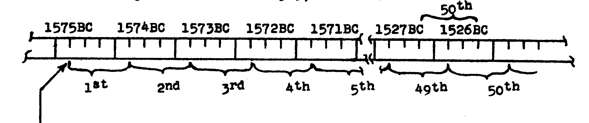
Entered Canaan In the
Spring of the year.
(1st Month by Jewish
Sacred Year)

18 X 50 = 900
1526 − 900 = 626
Thus the first Jubilee year was finished in Autumn of 1526 BC. The remaining 18 Jubilee Periods encompass 900 years and lead to Autumn of 626 BC as the finish of the 19th Jubilee attempted by Israel.
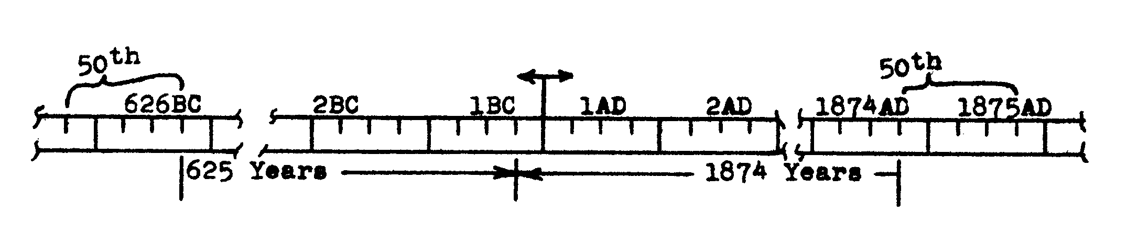
From Autumn 626 BC to
Autumn 1 BC is 625 Years.
From Autumn 1 BC to Autumn
1874 AD is 1874 Years.

Thus one sees that there are 625 + 1874 = 2499 years in all elapsed from the last Jubilee the LORD required of Israel (prior to the desolation of the land) to the beginning, of the antitypical Jubilee in October (Autumn) 1874. Note that if one includes the last 50th or Jubilee year this would make 2500 years in all to October 1875. This last “Jubilee” year now being a 1000 years in length, however, and beginning in October 1874 exactly on time.
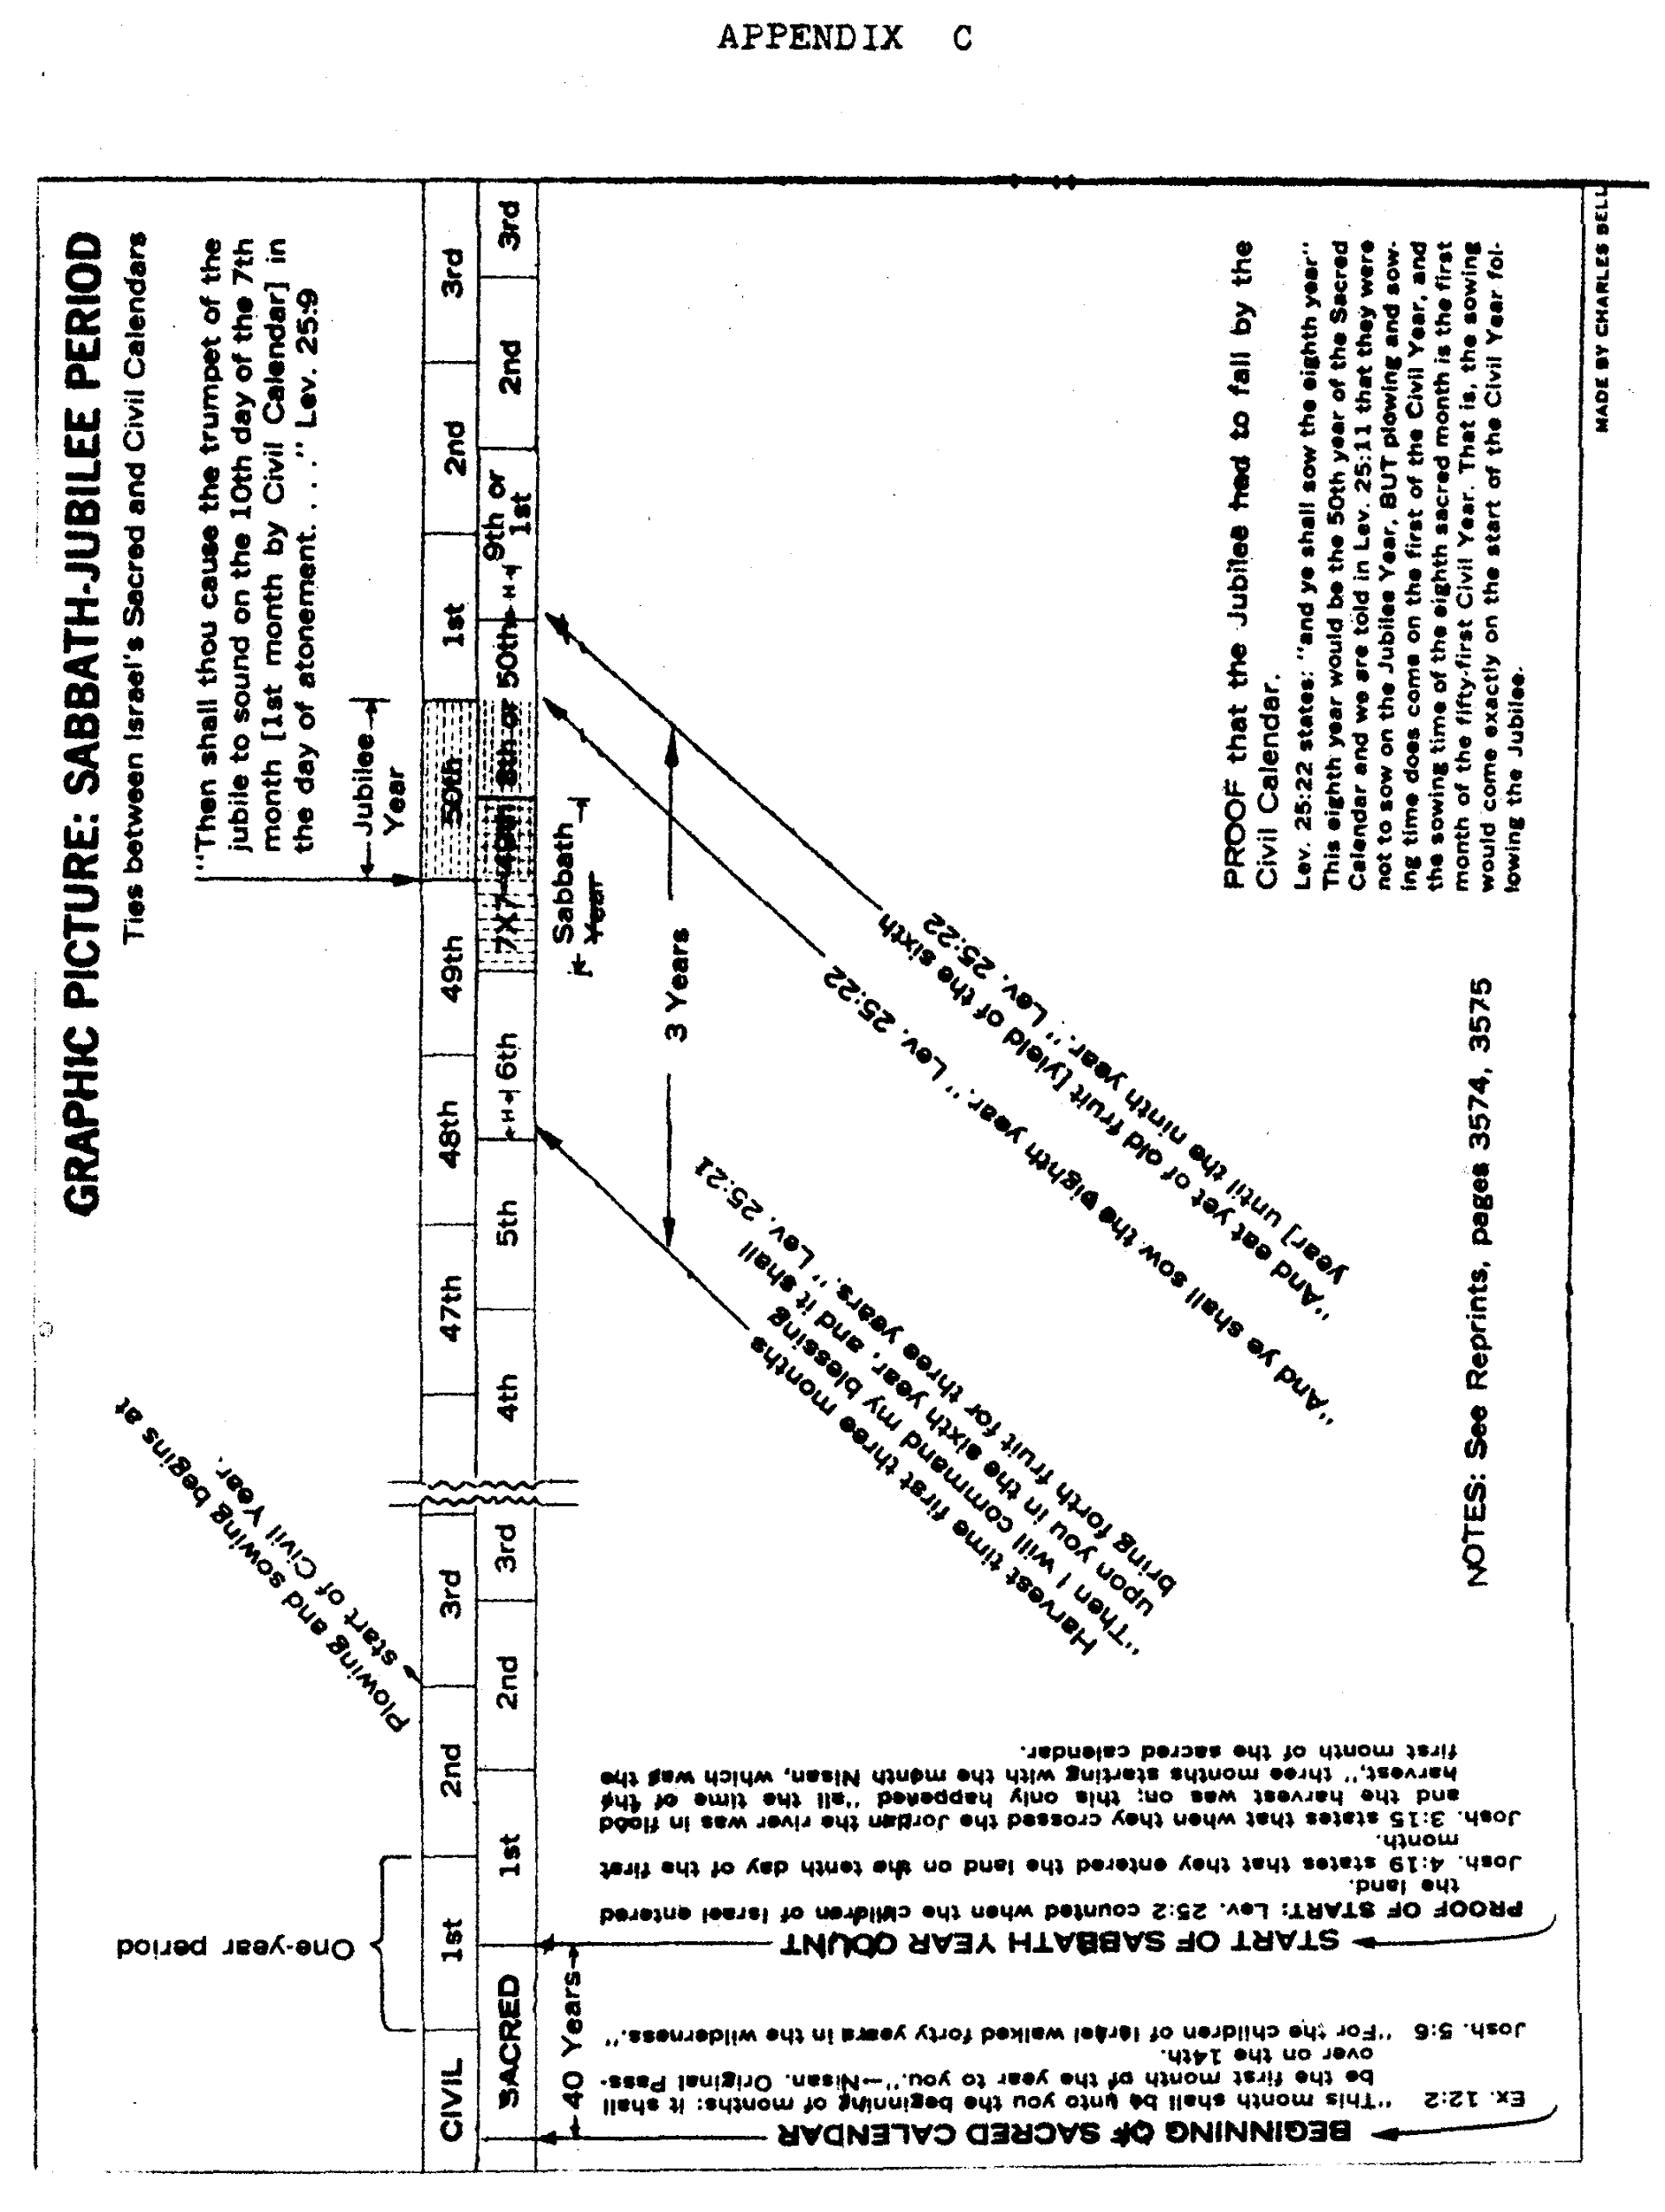
APPENDIX D

